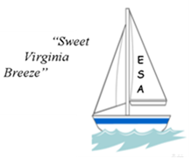
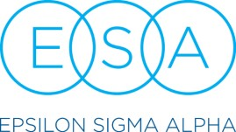
2026 INTERNATIONAL CONVENTION
“Sweet Virginia Breeze”
July 15 – July 19, 2026
Sheraton Norfolk Waterside Hotel
777 Waterside Dr., Norfolk, VA 23510
(757) 622-6664
MEMBER NAME MEMBER NUMBER/STATE / ADDRESS CITY, STATE, ZIP
CELL # EMAIL CHAPTER NAME CHAPTER # STATE COUNCIL DATE OF ARRIVAL TIME OF ARRIVAL FLY DRIVE USING SCOOTER Y N
DO YOU NEED A NAME BADGE HOLDER? Y N
ROOMMATE(S)
*Each registered guest will receive an email confirmation after form and payment has been received*
CHECK ALL THAT APPLY
First IC Convention Pledge ELAN Collegiate Member – Campus MC Staff ESA Foundation Board IC Elected/Appointed Board Past IC President (year) 2025-2026 State President – State 2026-2027 State President – State Previous State President - State(s)/Year(s) Served with: I will be recognized at convention for my years of ESA Service 25-80 years in 5-year increments: Dietary Restrictions: The hotel will do its best to accommodate DIETARY RESTRICTION requests only.
Restriction or Allergy alert: (Additional costs may apply)
CIRCLE AMOUNT

MEMBER FULL REGISTRATION FEE: Postmarked by May 1, 2026 $300
Includes general assemblies, workshops, After May 1, 2026 (see payment note on page 2) $350
welcome party, recognition luncheon, Saturday
luncheon, and banquet

MEMBER FRI. & SAT. REGISTRATION FEE: Postmarked by May 1, 2026 ………………………. $275
Includes general assemblies, recognition After May 1, 2026 (see payment note on page 2) $325
Luncheon, Saturday luncheon and banquet

MEMBER SAT. ONLY REGISTRATION FEE: Postmarked by May 1, 2026 $175
Includes general assembly, Saturday luncheon and After May 1, 2026 (see payment note on page 2) $225
banquet

MEMBER/NON-MEMBER WALK-IN REGISTRATION FEE:
Includes everything in full registration See payment note……………………………………$375
*PICPA STATE PRESIDENT’S LUNCHEON ( ADDITIONAL FEE) …………………………………………$ 45
(all past and present state presidents/IC presidents)

*If served with multiple IC presidents, indicate with whom you wish to sit?
SUBTOTAL MEMBER REGISTRATION: $
CONVENTION HOTEL ROOM RATES
Single/Double; Triple, Quad - $169 plus tax, plus $3.00/night fee.
To receive the group rate, you MUST make reservations by June 23, 2026.
In House Reservations at (757)622-6664; reference code: ES1
or click on the link: Book your group rate for Epsilon Sigma Alpha 2026 International Convention

Page 1 of 3

Member Name and Number as listed on first page: __________________________________________________
MEMBER MAY NOT REGISTER AS NON-•‐MEMBER FOR ANY EVENT

NON-•‐MEMBER NAME
Please indicate if special guest of the following:  ALSAC  EASTERSEALS  INCOMING IC PRESIDENT
 OTHER (Please specify)
CIRCLE AMOUNT
NON-MEMBER FULL REGISTRATION FEE: Postmarked by May 1, 2026 $300
Includes general assemblies, workshops, After May 1, 2026 (see payment note below) $350

welcome party, recognition luncheon, Saturday luncheon and banquet
NON-MEMBER attending WELCOME PARTY:

Postmarked by May 1, 2026………………………. $ 90
After May 1, 2026 (see payment note below) $140

NON-MEMBER attending RECOGNITION Postmarked by May 1, 2026…………………………$ 75
LUNCHEON: After May 1, 2026 (see payment note below) $125

NON-MEMBER attending BANQUET: Postmarked by May 1, 2026………………………. $100
After May 1, 2026 (see payment note below) $150

YOUTH REGISTRATION FEE (age 12 & under): Postmarked by May 1, 2026 $125
Includes general assemblies, workshops, After May 1, 2026 (see payment note below) $150

welcome party, recognition luncheon, Saturday

luncheon and banquet
YOUTH REGISTRATION FEE (age 13-17): Postmarked May 1, 2026 $175
Includes general assemblies, welcome party, After May 1, 2026 (see payment note below) $200

recognition luncheon, Saturday luncheon and banquet

***List dietary restrictions for non-•‐members on page one,
indicating who has the restriction.
SUBTOTAL NON-•‐MEMBER REGISTRATION: | $
ENTER TOTAL FROM FIRST PAGE: | $
TOTAL REGISTRATION: | $

MEN’S GOLF - Indicate day(s) you would like to play golf - ☐ Wednesday ☐ Thursday ☐ Friday ☐ Saturday

SELECT ONE PAYMENT TYPE: - ☐Check ☐Zeffy® see next page ☐Zelle® see next page

PAYMENT NOTE: Payment AFTER MAY 1, 2026 must be paid by MONEY ORDER, CERTIFIED CHECK, OR CREDIT CARD AND MAILED TO THE IC REGISTRATION CHAIR BEFORE JUNE 1, 2026.

After JUNE 1, 2026 - MAIL REGISTRATION FORM ONLY – DO NOT SEND PAYMENT. EMAIL the registration chair (susancaldwellva.comcast.net) indicating that the form has been mailed and bring a copy of the registration form with money order, certified check, cash or credit card to the IC Convention.

Make Check or Money Order payable to: 2026 ESA IC Convention (A $45 fee will be assessed for any returned check.)

Zeffy® registration has been added for Credit Card Payment. It is on the ESA Website - www.epsilonsigmaalpha.org under IC Convention

If you CANNOT use Zeffy® for any reason and need to pay by credit card, use Zelle®, or call Susan Caldwell @ 804-690-6378.

CANCELLATION: If you find it necessary to cancel this registration, the full amount less a $50 processing fee will be refunded when WRITTEN cancellation is postmarked NO LATER THAN JUNE 15, 2026.
NO REFUNDS AFTER JUNE 15 – TRANSFER ONLY.

TRANSFER TO ANOTHER MEMBER: One time transfer allowed, $15 transfer fee. See separate form.
Mail registration form with payment to: Susan Caldwell
Online Registration form can be found ESA IC Registration Chair
at www.epsilonsigmaalpha.org. 13932 Krim Point Way
Midlothian, VA 23114

Page 2 of 3

Zelle QR Code
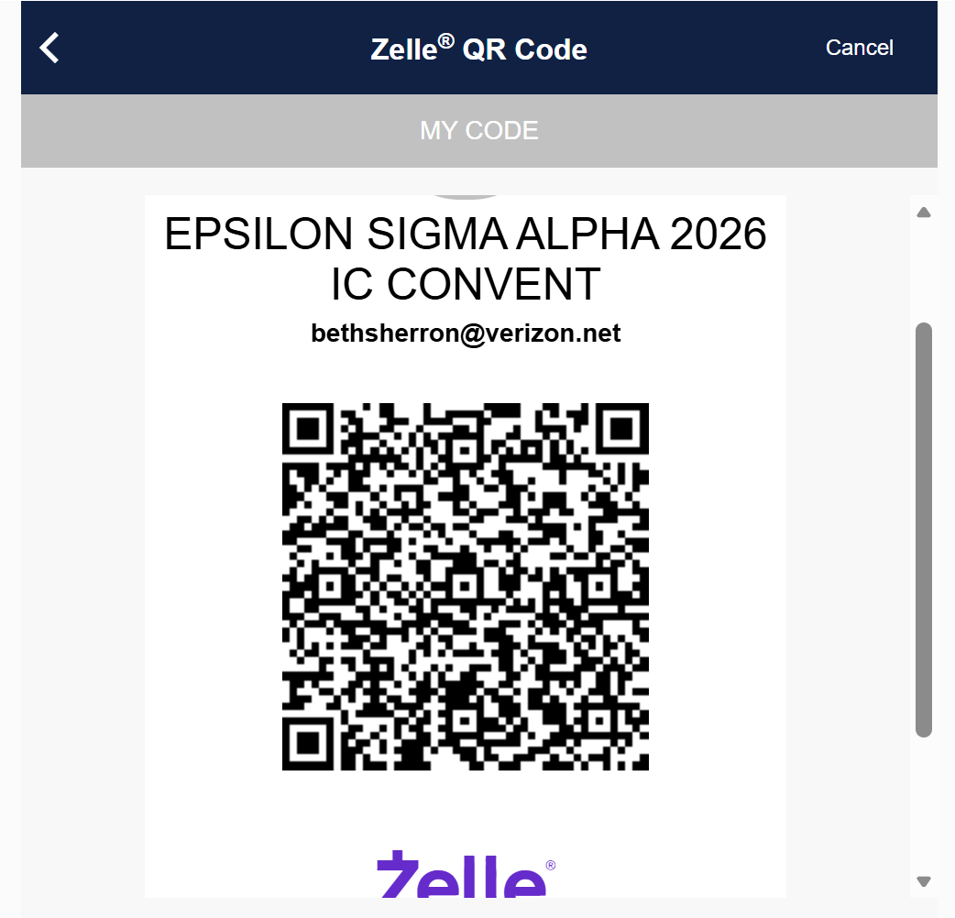

Zeffy – Member full registration
https://www.zeffy.com/en-US/ticketing/ic-convention-2026-sheraton-norfolk-waterside-hotel-virginia-members-only-copy


Zeffy -Non-members and Youth Registration
https://www.zeffy.com/en-US/ticketing/ic-convention-2026-sheraton-norfolk-waterside-hotel-non-members-and-guests-only-copy


Ads in program book
https://www.zeffy.com/en-US/ticketing/advertising-order-form-for-program-book-copy



Page 3 of 3

