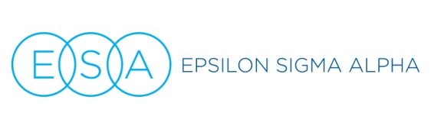
Podium Talking points: Hope for Heroes

- About (ADD INFO ABOUT THE ORGANIZATION BENEFITING FROM YOUR PROJECT TODAY… VFW, WOUNDED WARRIORS ETC… ADD SOME TALKING POINTS FROM THEIR WEBSITE OR LET THEIR REPRESENTATIVE SAY A FEW WORDS)
- About ESA and Hope for Heroes: ESA first began supporting the troops rolling bandages in World War II, and while the needs of our brave military members and veterans have changed over the decades, our desire to support them has not. ESA members across the country through our Hope for Heroes program support not only large national charities but also scores of local military support organizations and individual service members. Whether organizing a Veterans’ Day parade for the whole community or quietly making Christmas happen for one deserving military family in our hometown, we love supporting those who sacrifice so much for us.
- We are ALL volunteers. We belong to Epsilon Sigma Alpha because we believe we have the power together to change the world, and because it’s FUN! In addition to Hope for Heroes, we also support St. Jude Children’s Research Hospital, Easter Seals Camp Hope, domestic violence and literacy causes, scholarships through our Foundation and scores of other local worthy causes. Our network of chapters is multi-national AND multi-generational, from college students to active seniors, and we are always keeping an eye out for others who might like to join ESA, spend time with good-hearted people, and make a difference with us. We’re so grateful you’re here today to help us support Heroes through (NAME THE CAUSE) and invite you to speak with one of the ESA members here today if you’d like to know more about joining ESA and helping with other great projects like this one. (tell them where in the room they can get more information)

